

23056_Green Warriors_Design Report

# Author’s Name: Abdus Samad Suhail Co-Author’s Name: Mohd Munazir Mairaj

1. **INTRODUCTION**

Team Green Warriors, participating for the 13th time, is a team of sophomore and junior engineering students giving their best to design a domestic-four-wheeled- lightweight electric vehicle which is ergonomic, aerodynamic, highly engineered and easily manufactured. Working along the central theme of E- Mobility, the team has been investigating and experimenting on various factors to make the designed vehicle up to the mark for the event by incorporating newly designed suspension and power transmission mechanism with minimum losses to enhance riding experience of the driver and complete the dynamic events including Endurance Run with a greater number of laps and achieve glory.

# SELECTION & DESIGN OF SUB-SYSTEMS

EffiQue consists an electric drivetrain. We have used SolidWorks for designing the subsystems. The aim of the drivetrain model is to deliver the power produced by the drivers to the driving wheel most efficiently.

# DRIVE TRAIN

Starting Torque: Ʈ=f*r where f=µs*N

N= percentage of weight of vehicle= (mg*X1)/(X1+X2) X1=12.9in; X2=27.1in;

mg= 2288.3N N= 653.28N

Ʈ=f*r= 0.07*653.28**0.33 = 15.09Nm

## Calculation of Torque:

Torque on rear sprocket,

Ʈ3=15.09Nm

No. of teeth on rear sprocket(T4)= 30 No. of teeth of sprocket on shaft(T3)= 22

Gear ratio=T4/T3=1.36 T2=11.09Nm

## Calculation of Speed:

N = (1/1.36)* 500 = 367.6

V= 367.6* 2* 3.14 *(14.9/1000) = 34.5 = 35 m/sec

Total reduction=3.144

Therefore, Nt (tyre) =282.96 rpm r (radius of wheel) = 13”

= 0.33m

As, V=r x w So V=0.33 x 3.144 x π x 148.75 / 60 V=8.07

m/s =29.07 Km/h

## Calculation of Acceleration :

Maximum tractional force = Fr – Ff = (Ʈmax/0.33) – Ff

={(40*2.909)/0.33- (240*9.8*.67*.025) =313.21N

So, max acceleration is given by: 313.21= 240 x a a = 1.3 m/s^2

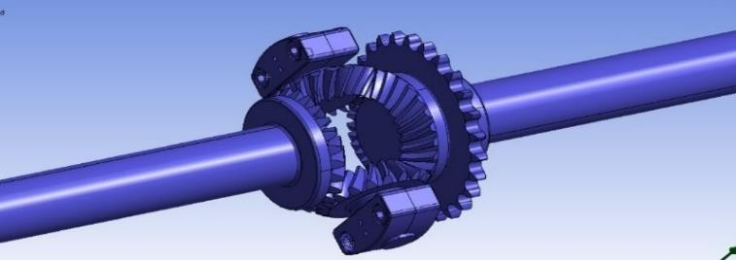

* 1. **DRIVE TRAIN – *ELECTRIC***

## Assumptions:

Drive train efficiency =90% Motor efficiency =85%

Depth of discharge of Battery= 85% Efficiency of chain drive = 80%

**Battery Specifications**: Lithium-ion,45 V, 35Ah MOTOR SPECIFICATIONS: BLDC Motor, 48 V,600

watt. Rated :500rpm Analysis and calculation of speed: Gear Ratio=1.27 S on shaft = (N5/N6)*Sm5

Sm1= (N2/N1)*S

S= (14/28)*500 =250 rpm Sm1= (22/14)*250=392.4rpm

=392.4*(2*3.14*.33*60)/1000

= 48.8 kmph

This speed is calculated by considering the efficiency of chain drive to be 80%.

## Runtime calculation:



* + 1. When motor shaft is not connected to the wheels: Min. Current Required = 9.8 Amps.

Maximum Allowable Capacity = 35 Ah After Considering 85 %

Depth of Discharge (DOD) ReduceCapacity=29.75Ah Runtime = 3.03 hrs.

Mechanical Efficiency (Friction and other losses)

= 75% Runtime = 2.27 hrs.

* + 1. Runtime of battery on different terrains:

F (Force required from the vehicle ) = (Acc. + Climb + Roll + Drag force (F= F(a)+F(h)+F(r)+F(d))

F= ma + mgsinα + µmgcosα + 0.5xCdρAv^2 On a level Road – Taking mass = 240 kg Acceleration = 0 m/s^2

Acceleration due to gravity = 9.81 m/s^2 Cd (coefficient of drag) = 0.04 Density of Air, ρ = 1.2 kg/m^3 Frontal Area, A = 0.16 m^2

Velocity (v) = 36 kmph(10 m/s) Inclination(α) = 0 ⁰

CONCRETE SURFACE – Fd =0.5 x 0.04 x 1.2 x 0.16 x

102 =0.384N

Pd = F.v = 3.84 W Fr = µmg

Coefficient of friction on Concrete surface = 0.02 Fr = 0.02 X 240 X 9.8 = 47.04N

Pr = F.v= 47.04 X 10 = 470.4 W

Total Power ( PT) = 473.88 W Since Motor Efficiency = 85 %

Power Input = 473.88/ 0.85 = 557.50 W P = VI 557.5 = 48 X I I = 11.6Amps

Considering DOD= 85 % , Motor efficiency=85% , Mechanical Efficiency = 90%

Runtime Of Battery = (35 X 0.85 X 0.85 X 0.75 ) / 11.6 =

1.63 hrs

## Asphalt:

Fd =0.5 X 0.04 X 1.2 X 0.16 X 102 =0.384N

Pd = F.v = 3.84

Fr = µmg

Coefficient of friction on Asphalt = 0.03 Fr = 0.03 X 240 X 9.8 = 70.56 N

Pr = F.v= 70.56 X 10 = 705.6 W

Total Power ( PT) = 709.44 W

Since Motor Efficiency = 85 % Power Input = 709.4/ 0.85

= 834.58 W

P = VI 834.58 = 48 X I I = 17.38 Amps.

Considering DOD= 85 % , Motor efficiency=85% , Mechanical Efficiency = 75%

Runtime Of Battery = (35 X 0.85 X 0.85 X 0.75 ) / 17.38=

1.09 hrs Grade ability:

On an Inclined Road: – Taking α = 15 ⁰ Velocity = 18 kmph =5 m/s

CONCRETE SURFACE: – Fd =0.5 X 0.04 X 1.2 X 0.16

X 52 =0.096N

Pd = F.v = 0.48 W

Fr = µmgcosα

Coefficient of friction on Concrete surface = 0.02 Fr = 0.02 X 240 X 9.8 X cos 150 = 45.53 N Pr = F.v= 45.53x5

= 227.19 W

Fh = mgsinα = 240 X 9.81 X sin150 = 609.36N Ph = F.v

= 3046.81W

Total Power ( PT) = 3274.48 W Power Input = 3274.48/ 0.85 = 6821.84 W P = VI 6821.84 = 48 X I I = 142.12

Amps. Considering DOD= 85 % ,

Motor efficiency=85% , & Mechanical Efficiency = 90% Runtime Of Battery = (35 X 0.85 X 0.85 X 0.9 )/142

=0.16hrs.

Asphalt – Fd =0.5 X 0.04 X 1.2 X 0.16 X 52 =0.096N Pd

= F.v = 0.48 W

Fr = µmgcosα Coefficient of friction on Concrete surface

= 0.02

Fr = 0.03 X 240 X 9.8 X cos 150 = 68.155 N Pr = F.v=

68.155 X 5 = 340.775 W



Fh = mgsinα = 240 X 9.81 X sin 150 = 609.36 N Ph = F.v

= 3046.81 W

Total Power ( PT) = 3388.07 W Since Motor Efficiency = 85 %

Power Input = 3388.07/ 0.85 = 3985.968 W P = VI 3985.968= 48 X I I = 83.041Amps.

Considering DOD= 85 %,

Motor efficiency=85% , Mechanical Efficiency = 90% Runtime Of Battery = (35 X 0.85 X 0.85 X 0.9 ) /83.04

=0.27h

# STEERING

## Steering Geometries Considered:

1. Ackermann Geometry
2. Davis Geometry

|  |  |  |
| --- | --- | --- |
| **Steering Geometry** | **Advantages** | **Disadantages** |
| **Ackerman** | Very little loss of energy as turning pairs are used.  It intends to avoid sideways slippage of the wheel when following a path around a curve.  Reduced steering effort.  Achieving pure rolling. | Less accurate on turns |
| **Davis** | Has sliding pairs. | It has too many moving parts which leads to wear and tear.  Expensive to make and maintain. |

## Geometry Selected:

We have adopted Ackermann Geometry for our vehicle since it offers an optimal steering effort to the turning

radius value. Additionally, it makes cornering easy for our trike.

## ▪️ Steering Geometry - Ackermann Calculations:

Track Width: a = 870 Wheelbase: b = 1339 Pivot to pivot: c = 796.21

Radius of outer wheel (Rof) = b/sin Φ + (a-c)/2 Let Rof = 3.5m

Let Φ = 22.74

cot Φ – cot θ = c/b

1/tan (22.74) – cot θ = c/b

cot θ = 1.7912 ̊ 1/1.8283 = tan θ θ = 29.17 ̊

cot θ avg = 2.088

R (turning radius) = 2860.02 mm Steering ratio = 360/22.74 = 15.83:1 **For Pinion:**

Let radius of steering wheel (r) = 180mm

Steering wheel travel for 1 complete rotation = 2πr

= 1130.97mm

steering ratio = 15.83

rack travel = 1130.97/15.83 = 71.44mm dpi = diameter of pinion

npi = no of steering wheel turns tpi = no of teeth on pinion

rack travel = π *dpi*npi

71.44 = π*dpi*1 dpi = 22.74mm let, module = 2





M = dpi/tpi

T = 11.37 ≈ 12

## For rack:

m = dpi/t pi = dra /tra → 22.74/12 = 22.74/tra

tra = 12

rack length = dpi*tpi = 272.88mm ≈ 273mm

**Ackerman angle** (α) = tan-1( {"mathml":"<math style=\"font-family:stix;font-size:16px;\" xmlns=\"http://www.w3.org/1998/Math/MathML\"><mstyle mathsize=\"16px\"><mfrac><mi>c</mi><mrow><mn>2</mn><mi>b</mi></mrow></mfrac></mstyle></math>","origin":"MathType for Microsoft Add-in"} )

α = 16.55 ̊

critical velocity = (μrg)1/2 = 15.78 km/h coefficient of friction is assumed to be 0.7.

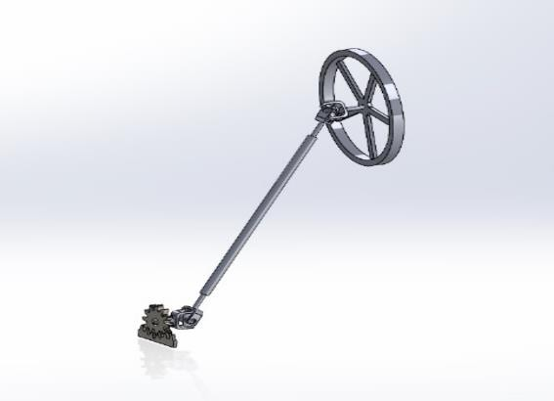

# SUSPENSION

**Type**: helical spring hydraulic suspension, **Specification**: 99 mm spring-loaded shock absorbers. Spring Dimensions: d = 8.3 mm; D = 50mm; c=06

Where, d = thickness of spring wire; D = Mean Diameter of coil

c = spring index calculation

The total mass of the vehicle with passenger = 250kg Total sprung mass = 210 kg

Total unsprung mass = 40 kg sprung mass (front) = 92 kg sprung mass (rear) = 118 kg unsprung mass (front) = 20 kg unsprung mass (rear) = 20 kg

Wheelbase = 1339 mm Track width = 870 mm H(C.G) = 322.3 mm

a = 736.45 mm (distance from the front wheel to the CG of the vehicle)

b = 602.55 mm (distance from the rear wheel to the CG of vehicle)

static load on wheel when vehicle is standing stationary with passenger.

w = wfs + wrs wfs * a = wrs * b

After solving above equation Wfs = w * b / a + b

Wfs = 250 * 9.8 * 602.55 / 1339 Wfs = 1102.5 N

Wrs = w * a / a + b Wrs = 1347.5 N

where wfs and wrs are the load on the front and rear wheels of the vehicle.

Longitudinal load transfer during acceleration Δw = m * g * H / L

Δw = 250 * 9.8 * 322.3 / 1339 Δw = 589.71 N

Where H = height of center of gravity of vehicle from ground

L = wheelbase

Total longitudinal load = 687.5 + 589.71 = 1277.21 N Lateral Load Transfer while turning

Load shared by front axle = .112.5 kg Load shared by single wheel = 56.25kg

Increase in load on the outer tyre while turning = Δw Δw = m*a*H/T





Where, m = mass of vehicle with passenger

a = lateral acceleration

H = height of center of gravity of vehicle from ground T = track width

Δw = 250*6.86*322.3/870 → Δw = 635.33 N

Total Lateral load shared by front single wheel while turning = 56.25*9.8+635.33

= 1186.58 N

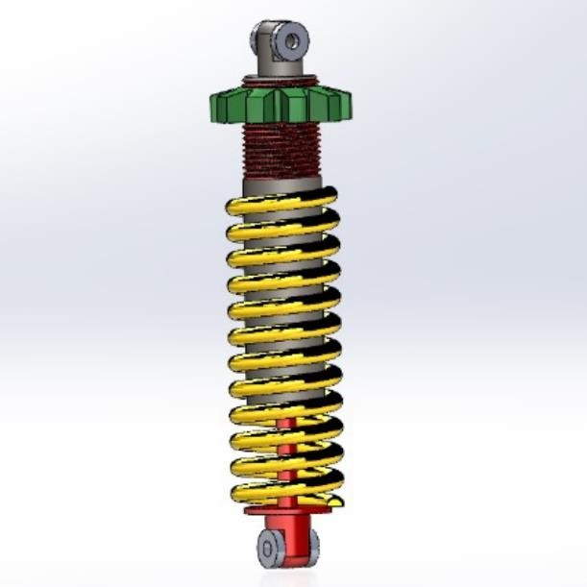

# WHEELS & TYRES

* 1. **BRAKING SYSTEM**

Total mass on the front axle:

(sprung + un-sprung) = 112kg Braking Distance = 5 m

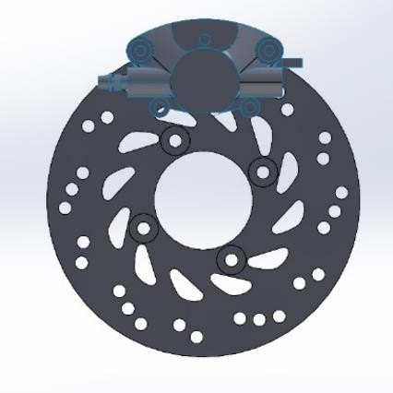

Maximum Velocity of the vehicle = 35 km/h

= 35 * 0.278

= 9.72 m/s

Using equations of motion,

𝑣2 − 𝑢2 = 2𝑎𝑆

Putting 𝑣 = 0, 𝑢 = 9.72𝑚𝑠−1, 𝑆 = 5𝑚

|  |  |
| --- | --- |
| FEATURES | SPECIFICATIONS |
| Size of Rim | 12” |
| Tire Width | 90mm -3.54inch |
| Wheel Diameter | 466.8mm -18.378inch |
| Static Toe Angle | 0° |
| Static Caster Angle | 7° |
| Static Camber Angle | 6° |

We get

𝑎 = −9.45𝑚𝑠−2

Or,

𝑎 = −0.96𝑔

Vehicle is traveling with some velocity and brakes are applied,

a= 736.45 mm, b= 602.55 mm, L= 1339mm,

𝐻𝐶𝐺 = 322.3 mm

𝑤𝑟𝑑 + 𝑤𝑓𝑑 = 𝑤 … … … … . (𝑖)

𝑤

𝐹𝑏𝑓 + 𝐹𝑏𝑟 = (𝑔) 𝛼𝑑 … … … … . . (𝑖𝑖)

𝑤𝑓𝑑 ∗ 𝑎 − 𝑤𝑟𝑑 ∗ 𝑏 = (𝐹𝑏𝑓 + 𝐹𝑏𝑟)𝛼ℎ

On solving, we obtain

𝑤𝑓𝑑

𝑤𝑟𝑑

𝑤𝑏

=

𝑎 + 𝑏

𝑤 ∗ 𝑎

=

𝑎 + 𝑏

𝑤 ∗ 𝑑 ∗ ℎ

+ 𝑔

𝑎 + 𝑏

𝑤 ∗ 𝑑 ∗ ℎ

− 𝑔

𝑎 + 𝑏



210 ∗ 602.55 ∗ 9.81 210 ∗ 0.95 ∗ 9.8 ∗ 322.3

= +

# SAFETY FEATURES OF VEHICLE

= 9.8 * 10

= 98 𝑁

1339

1339

1. Seat belts: retracting type seat belts
2. Kill switches: used to stop all electrical systems

Total vertical load on wheel during braking,

= 𝑤𝑓𝑑 + Load due to un-sprung balance

= 1396.69 + 98

= 1494.69 𝑁

Frictional Force = 𝜇𝑓 ∗ Total vertical load on one wheel

during braking

= 0.6 * 1494.69

= 896.81 𝑁

## Braking Torque

Braking torque on the wheel is the effect of the frictional force acting in the contact path of time.

𝐵𝑟𝑎𝑘𝑖𝑛𝑔 𝑇𝑜𝑟𝑞𝑢𝑒(𝑇𝑏)

= 𝐹𝑟𝑖𝑐𝑡𝑖𝑜𝑛𝑎𝑙 𝑓𝑜𝑟𝑐𝑒 ∗ 𝑅𝑎𝑑𝑖𝑢𝑠 𝑜𝑓 𝑡𝑖𝑟𝑒(𝑅)

= 896.81 ∗ 0.2332

= 209.13 𝑁𝑚

Force exerted on caliper mounting (𝐹𝑐)

𝐹𝑐 = 𝑇𝑏

𝐷𝑖𝑠𝑡𝑎𝑛𝑐𝑒 𝑓𝑟𝑜𝑚 𝑐𝑒𝑛𝑡𝑒𝑟 𝑜𝑓 𝑠𝑝𝑖𝑛𝑑𝑙𝑒 (𝑟)

209.13

=

0.062

𝐹𝑐 = 3373.06 𝑁

Moment of reaction forces due to braking and force

exerted on the caliper is taken about the center of the spindle.

𝐹1 ∗ 𝑏 − 𝐹2 ∗ 𝑎 + 𝐹𝑐 ∗ 𝑟 = 0

𝐹1 ∗ 0.066 − 𝐹2 ∗ 0.067 + 209.12 = 0

𝐹1 ∗ 0.066 − 𝐹2 ∗ 0.067 = −209.12

Net Horizontal force,

𝐹1 + 𝐹2 = 896.81𝑁

𝐹1 ∗ 0.067 + 𝐹2 ∗ 0.067 = 60.08

Solving these equations we get,

𝐹1 = −1120.60𝑁 (Towards right)

𝐹1 = 2017.41𝑁 (Towards left)

# SEATS

Both the seats are arranged in adjacent configuration. These are made up of plywood.

**Seat Back angle**= 15 deg

**Seating height** (a point) =26 inch

during any emergency.

1. Proper shielding provided to the battery to protect it from water splash, mud and dust etc. and to maintain the safety of drivers as well.
2. Proper insulation techniques used to ensure that there are no safety hazards due to electric short circuit, poor component mountings etc.
3. Seat Belt Reminder to provide alert to the drivers if they are wearing seatbelts.
4. Mudguard: the mud guard stops the flying mud from making a mess and flying rocks from causing damage to the vehicle or other vehicles.
5. Chain cover: to protect clothes from oil and dirt which spread from the chain by using it, chain covers were
6. Over 80 percent of all road traffic accidents occur in darkness and bad weather. By using these headlights, we can prevent most of the accidents.
7. **ERGONOMICS & COMFORT FEATURES**

Ergonomics of seats:

* 1. A seat back angle of 15 degrees is relatively upright.
  2. It promotes a neutral spine position, pelvic tilt, and ease of movement.
  3. Suitable for short-term tasks, providing comfort and versatility.
  4. Ideal for environments where users need to be alert and engaged.
  5. Consider other ergonomic features for a comprehensive design.

# INNOVATIONS

## POT-HOLE DETECTION AND NOTIFICATION SYSTEM

* BASIC IDEA AND APPROACH

The road network of India is about the second largest in the world with a total length of 4,320,000 kilometres.While India has about one percent world's vehicle population it also accounted for about 6 percent of the global road traffic accidents. Potholes claimed 11,836 lives and left 36,421 persons



injured in India from 2013-2016. What if we have a system in our vehicles which informs the driver about the potholes and obstacles beforehand. This became our source of inspiration for using this system in our hybrid vehicle. With this approach, accidents can be prevented by assisting the driver by informing him when another vehicle and potholes are nearby.

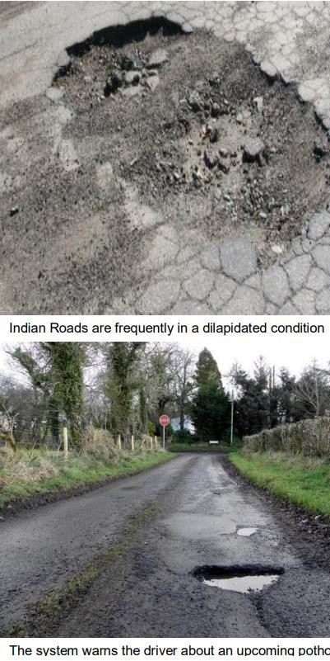

* Introduction

The objective of this project is to detect the potholes on the road. First, the survey or a

preliminary run is conducted and the potholes are detected and plotted onto the maps. Users can login to the map and can see the location of the potholes on the map. This will help the user to avoid potholes and will result in the reduction of accidents. When the pothole is removed from the road, the location of the potholes can be manually deleted from the database.

1. USER SYSTEM
   1. Login: User logs in to its account using its id and password given during registration.
   2. Access: The accelerometer detects a pothole and geotag the location with latitude & longitude using GPS and GPRS and geotagged.

The coordinates are sent to the server and the location is recorded through user interaction and input.

* 1. Upload: This information gets uploaded to the server

to be accessed later by authorities or other drivers.

1. SERVER-SIDE SYSTEM.
   1. Upload: Location via WIFI Module is uploaded to the webserver then it goes to the data mining server. The pothole server store & the pic for further processing and authenticity.
   2. Server: It stores the content uploaded and all the privileges to the admin section is provided through this server because server administrator cell is the authenticator and authorizer of the content uploaded

* PROPOSED SYSTEM

Pothole sensor plugin uses vehicle accelerometer (x, y, z axes) and GPS for detecting potholes. Generic design for versatile context-aware applications.



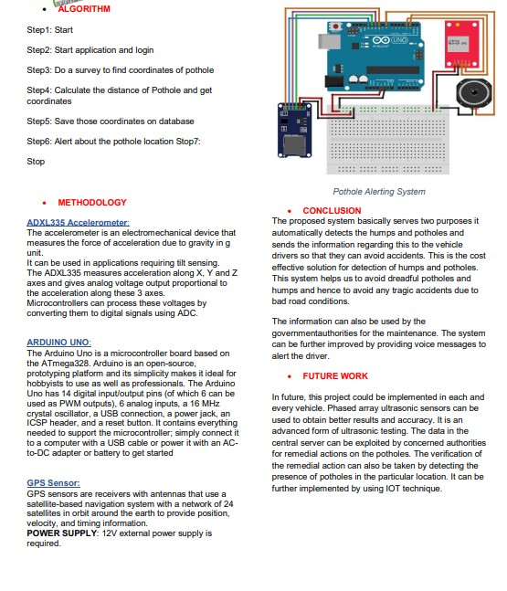



## APPENDIX-1 : PICTORIAL PRESENTATIONSd

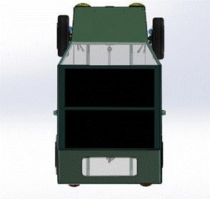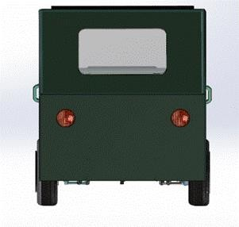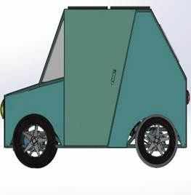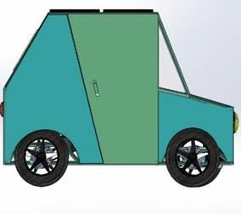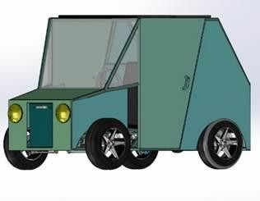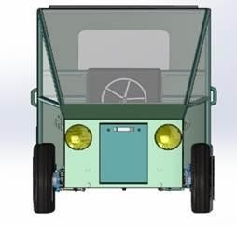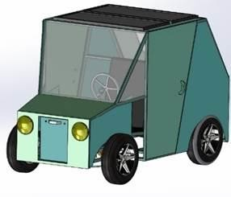

Vehicle Views



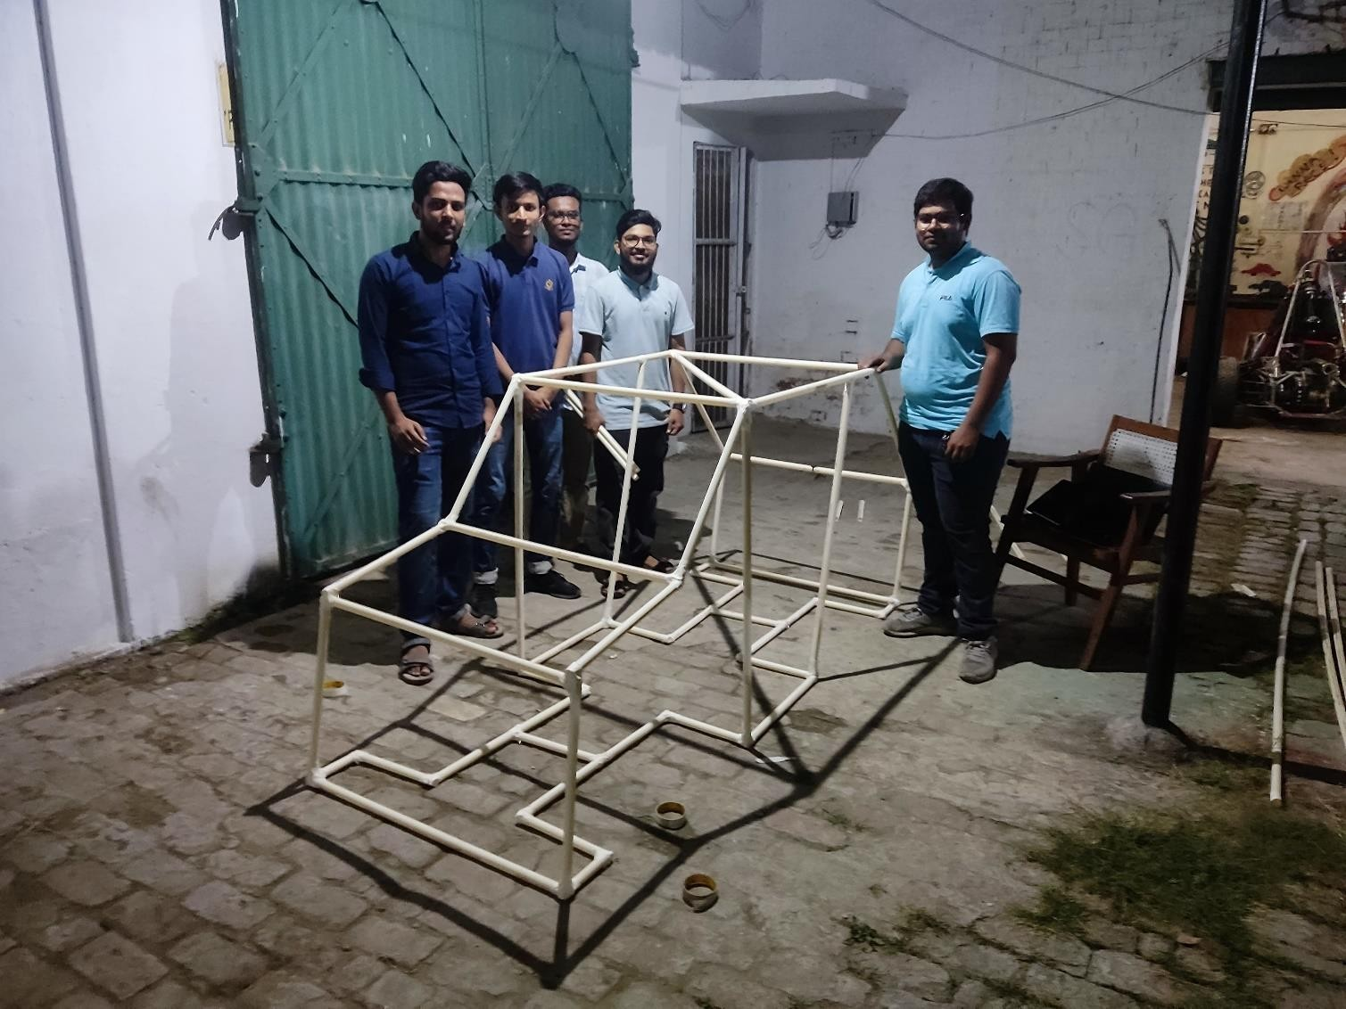

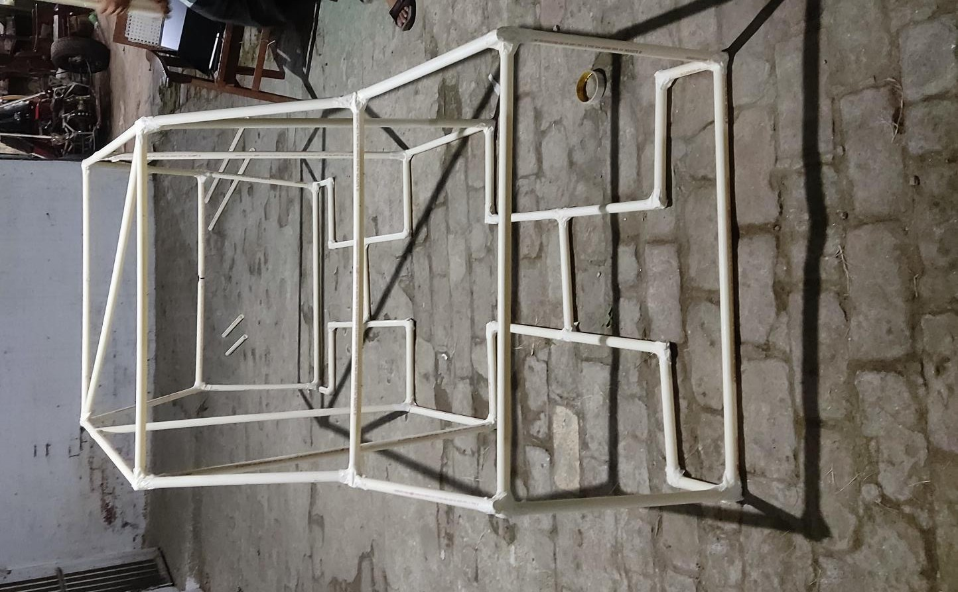

Prototype chassis developed by team using PVC pipes



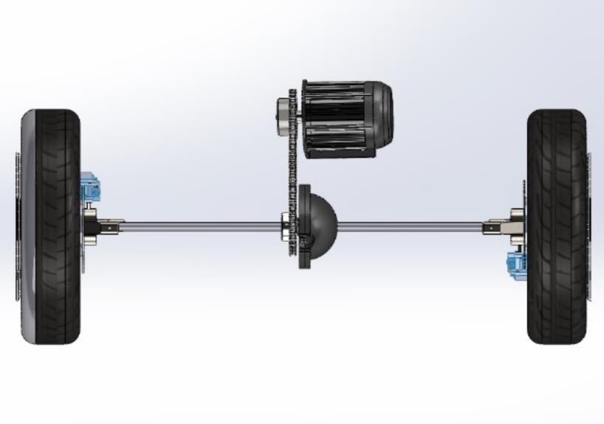

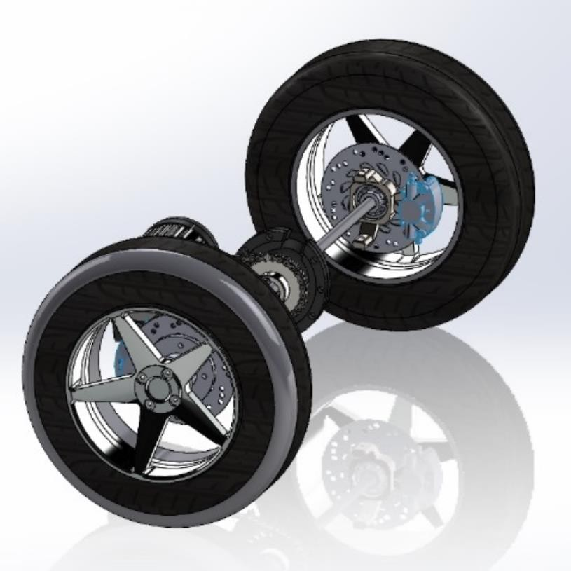

Subsystem – Powertrain



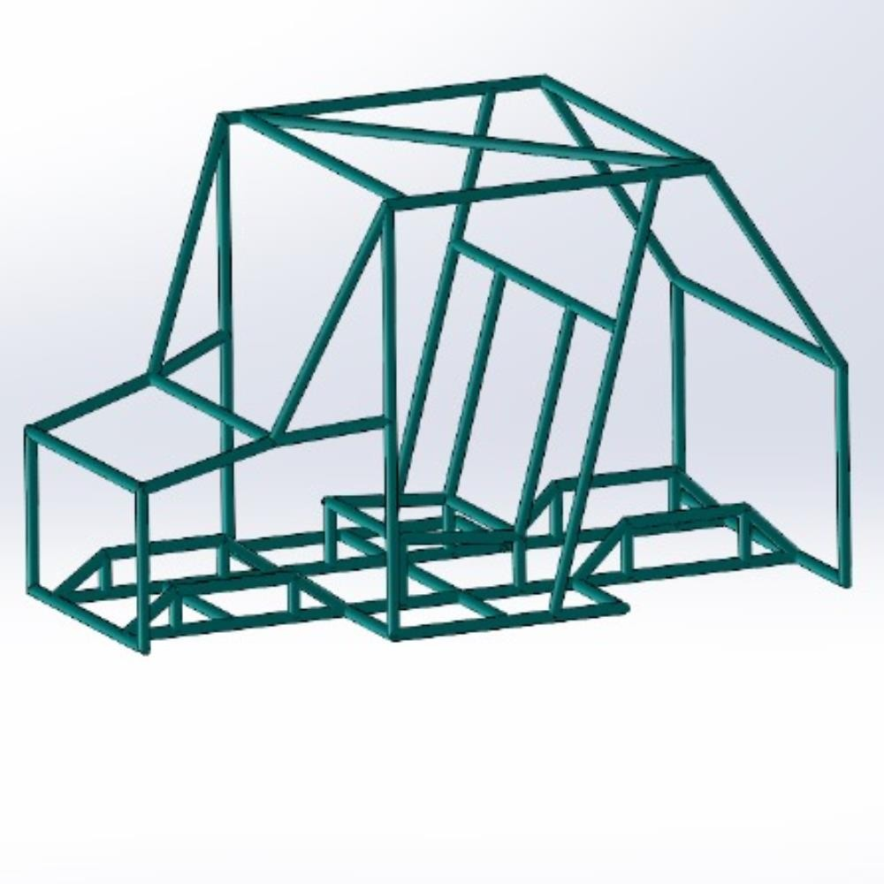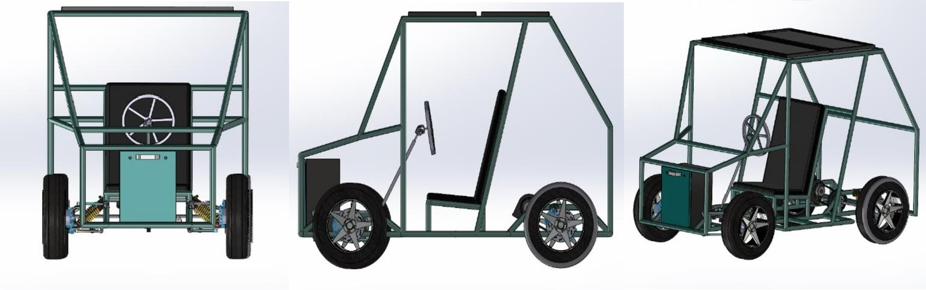

Subsystem- Chassis ans Seats

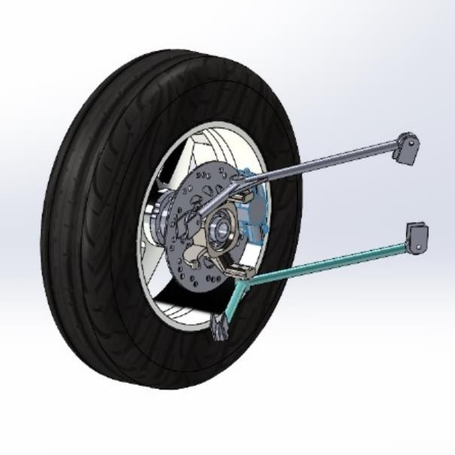



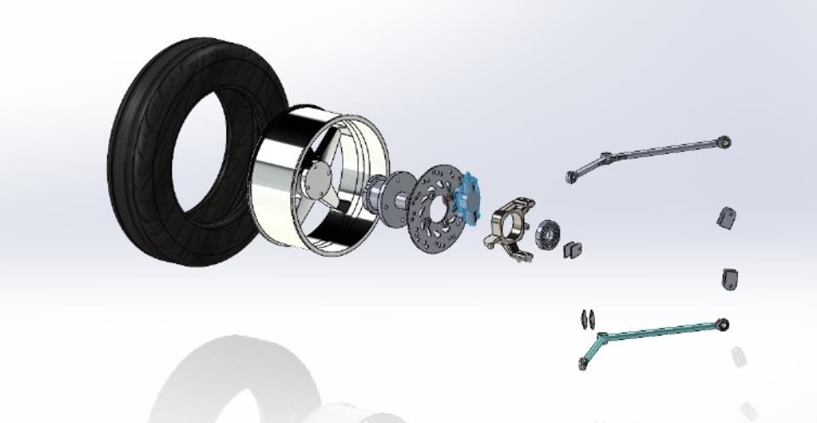

Subsystem- Wheels and Brakes





